Prototypes & Design Ideas
Teams will submit one document discussing how their prototypes link to design ideas discussed in class.
Bryanna
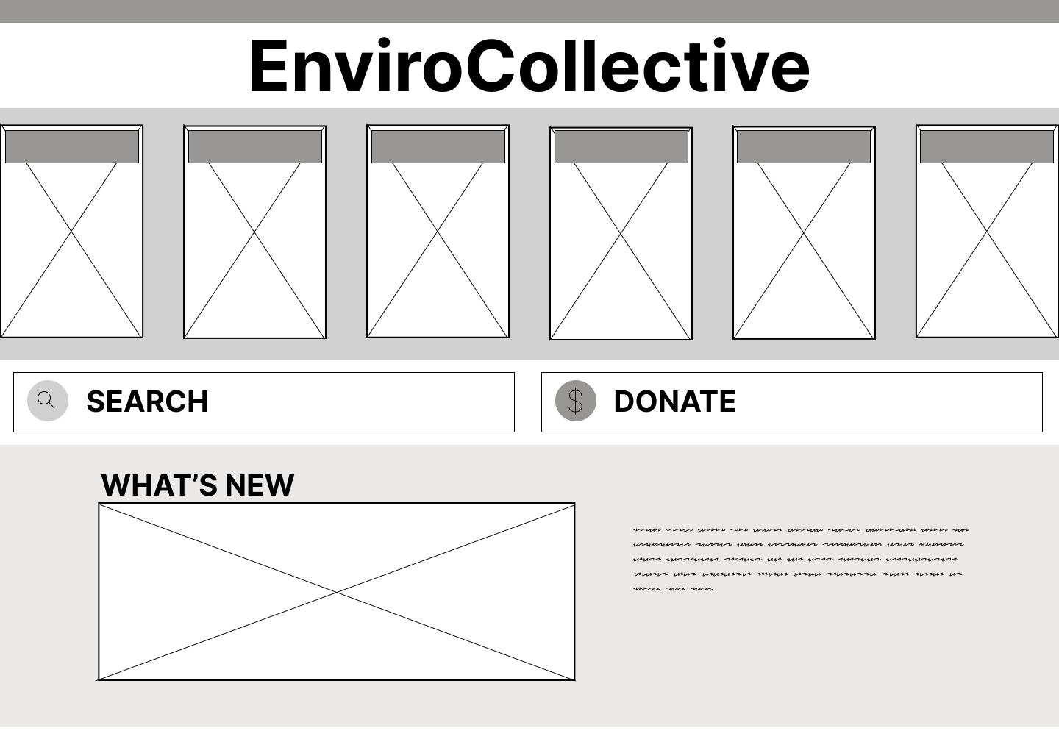
My prototype features the design ideas of a searchable database, Pollinator navigation, donation prompt, imagery and general appeal and usability. My design features 6 headers and images for each area of navigation including: resources, about, newsletter, events, volunteers and Repair Cafe. This grouping reflects the gestalt idea that items placed in a close proximity belong together, which is why I placed many of the primary website navigation together. I decided to pair each prompt in the navigation bar with an image for both design appeal and to further indicate what the organization does by incorporating visuals of their work. If the user is to hover over one of these options a drop down list is to appear answering the question of “what can I do here?”. One of the most noted design features was a searchable database for the newsletter, the Pollinator, the client said that this is a major feature that draws people into the organization. Another key compelling aspect is their Repair Lab, in another prototype I would hope to incorporate this on a greater scale in addition to the navigation menu feature. I would do this in a similar manner to the Pollinator.

Lei-Ann
The big user question for my prototype is “will the website offer sufficient information and resources for users to regularly come back to this site?” After my discovery that the client preferred functionality over visuals due to budget, I immediately understood that their biggest concern was regarding the volunteering availability and unavailable bookings when online booking a repair session. Therefore, I worked on the page for booking and added on a volunteering section as well. Both sections have similar attributes such as an information section, following a step-by-step procedure, entering in required personal information, and sending a form or a request. The use of buttons was a crucial component for functionality. Therefore, I prioritized practicality, resulting in fewer images that help users get familiar with the component they are associating with. For example, a visual demonstration of a service or who their repair person is rather than appealing images that focuses on aesthetics and website attraction. Additionally, the buttons showcase an affordance concept as they are clickable and enable users to move onto a new page. The texts associated in the buttons are signifiers for users to recognize where to click and what to do. Similarly, the text is also a feedforward concept as it explains what will happen before clicking. Finally, the feedback concept is the confirmation of a booking or the confirmation of a completed volunteering application. Moreover, the buttons also follow the Gestalt principle of similarity as the online booking buttons share the same colour of blue while the volunteering buttons are green. Further, the visual appearance of the starting page at 0.0 also follow the Gestalt principle of proximity. Each sections are grouped by distance as the booking and volunteer sections are fairly spaced apart with their associated components being close together. Overall, the application of these user-centred designs, especially the purpose of buttons for practicality over visuals, helped me build a starting foundation and the most basic performance of booking and volunteer applying.
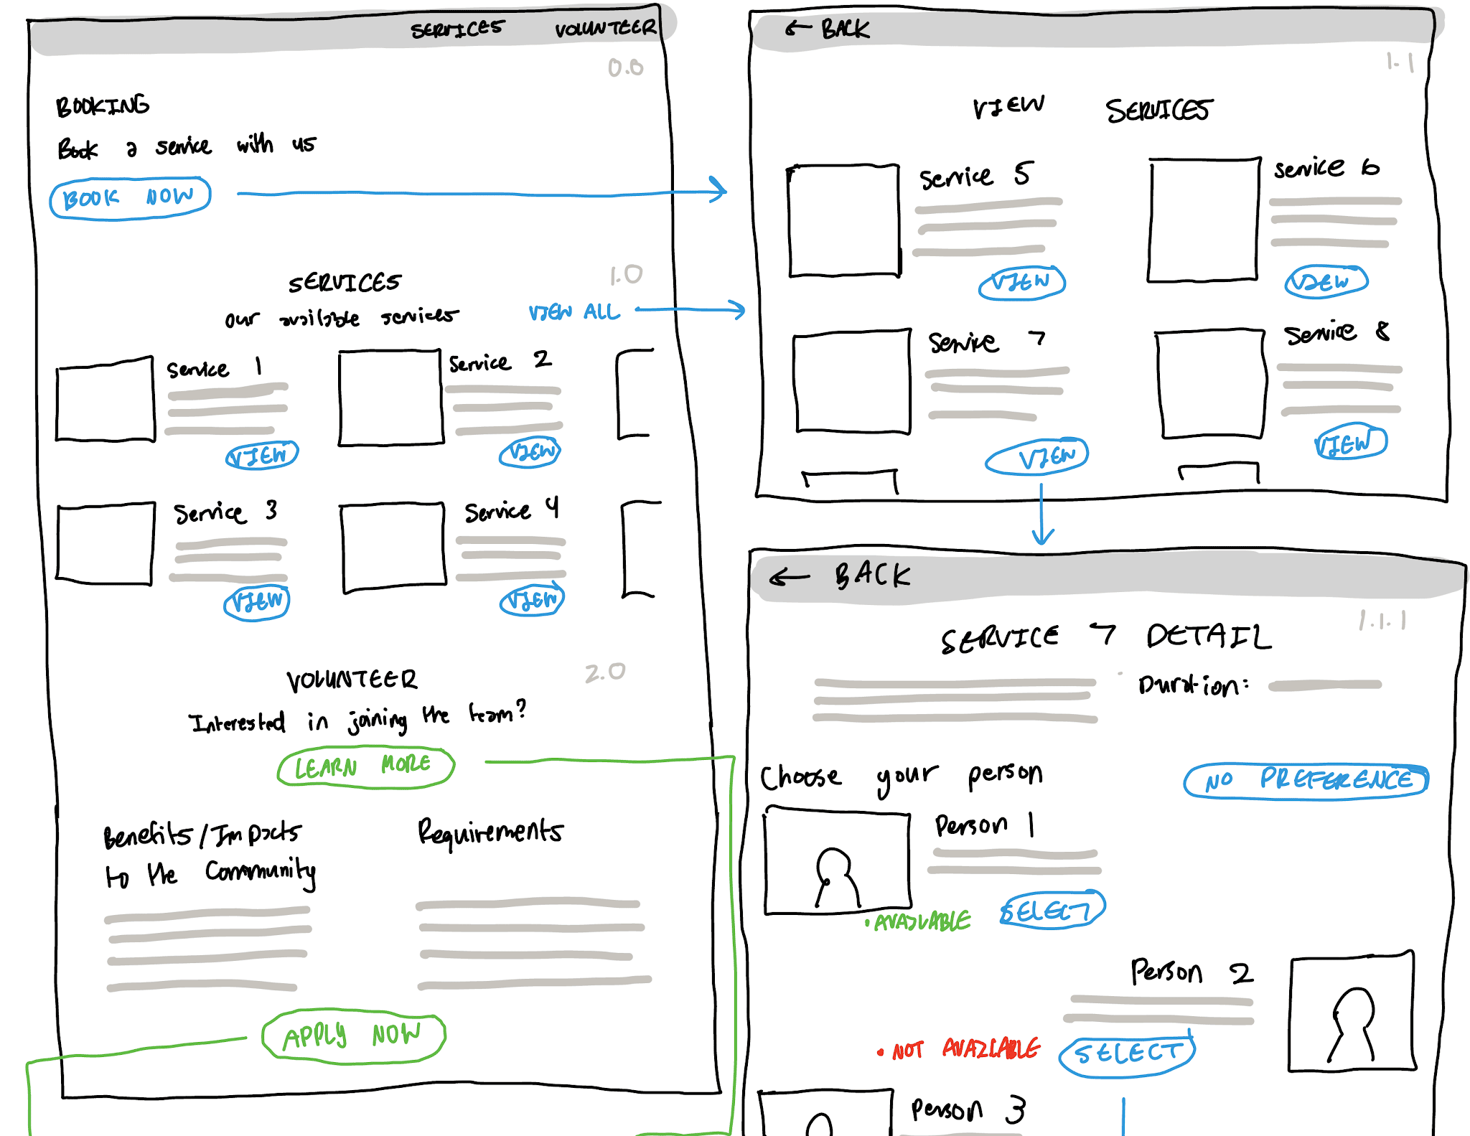
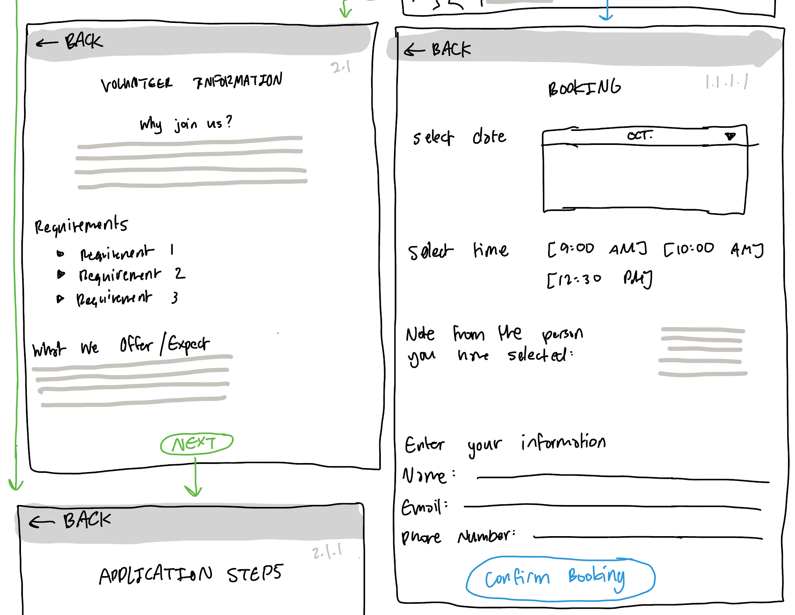
Similarly, the same key idea of functionality over visuals is applied in the admin portal page. Fewer images are added that serve core purposes like charts, graphs and percentage successful rates than website aesthetics. The dashboard, bookings, volunteers, services, and logout sections are also grouped by distance as their associated components are closely together, associated subsections are spaced apart, and each have their individual pages. Their associated buttons are also colour coded such as the booking portal being blue.
